EXP.NO: 2 Create a web form that accepts a user’s name and age. Write a Servlet to process Date :6/2/2025 the form data and display it back on the browser
Aim:
To write a basic Servlet program that demonstrates the use of Java Servlets by printing
“Hello, World!” when accessed through a browser.
ALGORITHM:
1. Input:
• The user fills out a web form with their name and age and submits it.
2. Form Handling and Servlet Processing:
1. Create the Web Form:
o Create an HTML form with two input fields: one for the user&#39;s name and one
for the user&#39;s age.
o Add a submit button to the form.
o Set the form&#39;s action attribute to the URL of the Servlet and the method to
POST (or GET).
2. Create the Servlet Class:
o Write a Servlet that processes the form data submitted by the user.
o The Servlet will override the doPost() (or doGet() depending on the form
method) to handle form submissions.
o The Servlet will retrieve the name and age parameters from the request
object using request.getParameter(&quot;name&quot;) and request.getParameter(&quot;age&quot;).

3. Process the Data in the Servlet:
o Extract the name and age values submitted from the form.
o Validate the input (e.g., check if the age is a valid number).
o Prepare a response that will display the user&#39;s name and age back on the
browser.

4. Send Response to the Browser:
o The Servlet will send a response to the browser containing a message like:
▪ &quot;Hello, [name]! You are [age] years old.&quot;
o The response will be displayed to the user in the browser.
5. Deploy the Servlet:
o Compile the Servlet and deploy it to a Servlet container (like Apache
Tomcat).
o Ensure the web.xml file or Servlet annotations are used to map the Servlet to
the URL defined in the form&#39;s action attribute.

6. Test the Application:
o Open the web browser, fill in the form with the name and age, and submit it.
o The Servlet will process the data and display the message back to the user in
the browser.
Code:
Index.html:
<!DOCTYPE html>
<html>
<head>
<meta charset="UTF-8">
<title>Movie Ticket Booking</title>
<style>
body {
font-family: 'Segoe UI', Tahoma, Geneva, Verdana, sans-serif;
background-color: #121212;
color: #f0f0f0;
display: flex;
justify-content: center;
align-items: center;
height: 100vh;
margin: 0;
}
form {
background-color: #1f1f1f;
padding: 30px;
border-radius: 12px;
box-shadow: 0 0 15px rgba(0,0,0,0.5);
width: 400px;
}
h1 {
text-align: center;
color: #05df98;
margin-bottom: 20px;
}
label {
display: block;
margin-top: 15px;
font-weight: bold;
color: #ddd;
}
input[type="text"], input[type="number"] {
width: 100%;
padding: 10px;
margin-top: 5px;
border-radius: 8px;
border: 1px solid #444;
background-color: #2a2a2a;
color: #f0f0f0;
}
input[type="submit"] {
margin-top: 20px;
width: 100%;
padding: 12px;
border: none;
border-radius: 8px;
background-color: #3399ff;
color: #121212;
font-weight: bold;
font-size: 16px;
cursor: pointer;
transition: 0.3s;
}
input[type="submit"]:hover {
background-color: #2673cc;
}
</style>
</head>
<body>
<form action="BookingServlet" method="post">
<h1>Movie Ticket Booking</h1>
<label for="name">Your Name:</label>
<input type="text" name="name" id="name" required>

<label for="hours">Number of Tickets:</label>
<input type="number" name="hours" id="hours" min="1" required>

<input type="submit" value="Book Ticket">
</form>
</body>
</html>
Userform.java:
package com.example;

import java.io.IOException;
import java.io.PrintWriter;
import javax.servlet.ServletException;
import javax.servlet.annotation.WebServlet;
import javax.servlet.http.HttpServlet;
import javax.servlet.http.HttpServletRequest;
import javax.servlet.http.HttpServletResponse;

@WebServlet("/BookingServlet")
public class userform extends HttpServlet {
private static final long serialVersionUID = 1L;

protected void doPost(HttpServletRequest request, HttpServletResponse response)
throws ServletException, IOException {

String name = request.getParameter("name");
String hours = request.getParameter("hours");

response.setContentType("text/html");
PrintWriter out = response.getWriter();

out.println("<html>");
out.println("<head><title>Booking Confirmation</title>");
out.println("<style>");
out.println("body { font-family: 'Segoe UI', Tahoma, Geneva, Verdana, sans-serif; background-color: #121212; color: #f0f0f0; display:flex; justify-content:center; align-items:center; height:100vh; margin:0; }");
out.println(".container { background-color:#1f1f1f; padding:30px; border-radius:12px; box-shadow:0 0 15px rgba(0,0,0,0.5); text-align:center; width:400px; }");
out.println("h1 { color:#05df98; margin-bottom:20px; }");
out.println("p { font-size:18px; margin:10px 0; }");
out.println("a { display:inline-block; margin-top:20px; text-decoration:none; color:#121212; background-color:#3399ff; padding:10px 20px; border-radius:8px; font-weight:bold; transition:0.3s; }");
out.println("a:hover { background-color:#2673cc; }");
out.println("</style>");
out.println("</head>");
out.println("<body>");
out.println("<div class='container'>");
out.println("<h1>Movie Ticket Booking Confirmation</h1>");
out.println("<p><strong>Name:</strong> " + name + "</p>");
out.println("<p><strong>Ticket booked:</strong> " + hours + "</p>");
out.println("<p>Thank you for booking your Movie Tickets!</p>");
out.println("<a href='index.html'>Back to Booking</a>");
out.println("</div>");
out.println("</body>");
out.println("</html>");
}

protected void doGet(HttpServletRequest request, HttpServletResponse response)
throws ServletException, IOException {
response.sendRedirect("index.html");
}
}

OUTPUT:
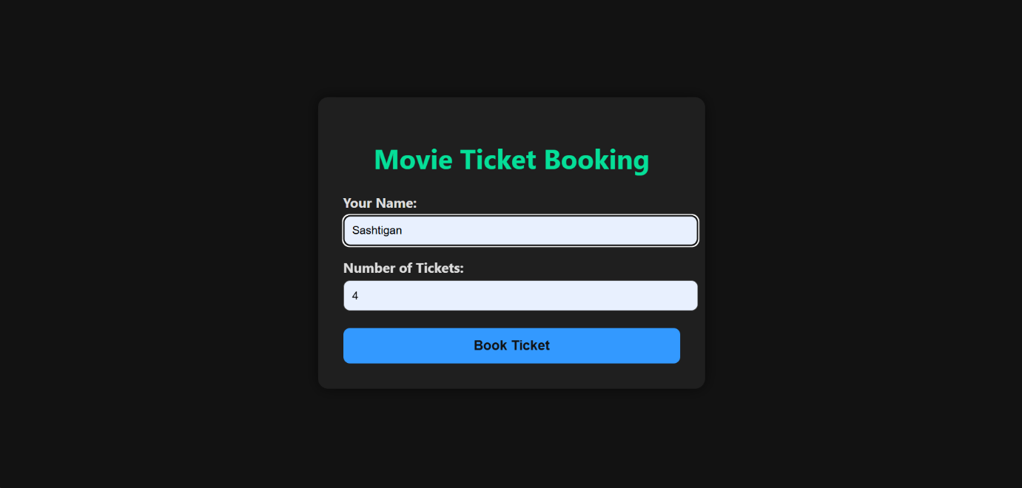
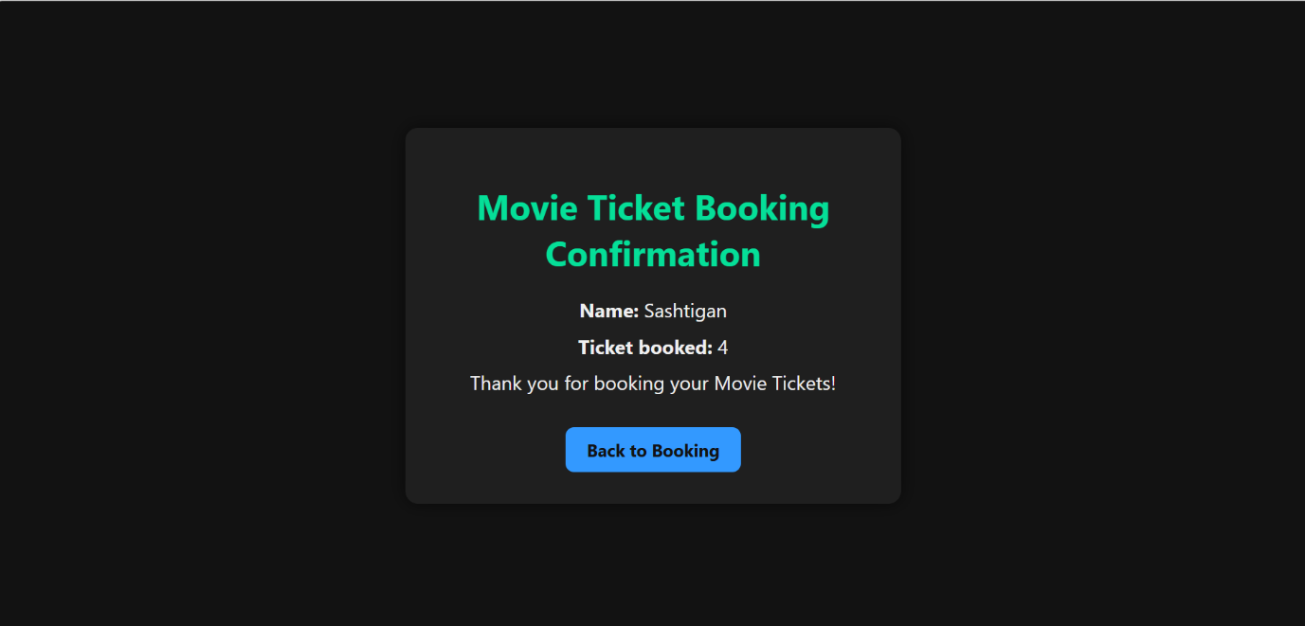

RESULT:
A Servlet is created to demonstrate the difference between HTTP GET and POST methods by creating a form and handling requests accordingly.

